1.

I find the myth that dinosaurs and humans existed together to be very interesting, though I did see a couple episodes of Flintstones growing up I never thought that they existed together. But one myth I did believe was that pterodactyls were dinosaurs. I believed in this myth till last year, it was a YouTube video that had enlightened me on this topic. The reason behind me believing this myth must be the dinosaur picture books I saw a as a kid and dino movies. Its amazing to think that not only were they not dinosaurs but that they lived like millions of years apart.

2.

Picture 1

By looking at this picture we can see that the layers at the bottom are older than the layers on top because of Superposition. From which we can also say that the layer at the bottom would be the oldest and the one on top would be the youngest. I can make out a fossil from one of the lower layers to be a Trilobite, these are great index fossils which allows us to date the layer numerically. On top of that the layers in which the fossils are present in seem to be made of volcanic ash which can also be used to date layers using radiometric dating.

3.

while many in the coming millions of years might die from the changing weather, it would still mean that a large portion could have survived by either migrating to someplace warmer, or evolving in someway that helps them brave the temperature. maybe even becoming warm blooded.   
1.) this might also in turn mean that the animals and plants of their current age might be alien to someone from our timeline. Instead of mammals being the dominant land creatures, There could have been more reptilian descendants who evolved to survive even the cold.   
2.) Maybe their survival postponed the existence of "humans" to many millions of years, or even  eradicated it entirely, and instead of us over a large span of time came different intelligent reptilian descendants. Or maybe they evolved to be intelligent around the same time as us, and we lived together in that world. How amazing and different would our cultures have been.

Idk num

Since vocal boxes are made of soft parts it does not fossil very well making it impossible to exactly pinpoint what dinosaurs sounded like. However, scientists believe that they can estimate a guess by looking at their evolved descendants’ birds and crocodiles. This though very different from the mainstream idea of what dinosaur sound like it is still very terrifying as in the case of tyrannosaurus rex, they said that not only would u be able to hear the low frequency sounds but also fell the vibrations made by it. They explained further that instead of opening its mouth and roaring which it couldn’t do as they didn’t evolve to have voice boxes, they would have used low frequency sounds and vibrations to communicate over huge areas in which they hunted.

They measured the speed of dinosaurs by looking at the distance between the footprints and the length of their legs. Huge dinosaurs with short legs were slow, while previously believed that the heavy plated dinosaurs were slow new tracks found in Bolivia show that they were not. However, the fastest of the dinosaurs were the birdlike bipedal carnivores with long and slim legs with light bodies. They were probably as quick as the modern-day Ostrich reaching speeds up to 43 mph. They measured these speeds using the Alexander’s equations which was derived from elephants, birds and people. I think this is valid as someone who has studied dinosaurs much more than me came up with it. One thing that might be a flaw is that the biggest animal the formula is derived from is an elephant.

In this podcast they talked about a couple paleontology related topics. The hosts talked about new Oviraptorosaur named Oksoko from Mongolia which had 2 fingers on each hand. The fossil is said be 70 million years old from the late Cretaceous period. The second story was about the redescription of Scelidosaurus which found that there were horn shaped osteoderms on the back of their head. While previously often depicted with more stegosaurus like head with no ornaments, the new horns are more hornlike than any other Ankylosaurus depictions. Norman the one behind this study called it an Ankylosauramorph. They also talked about the sale of a T-rex named “stan” which I found very interesting; the fossil sold for a staggering $31.8 million. I did not know that fossils could be purchased by private parties, seems like a very bond villain thing to do. Many public institutions did not bid for stan because the sale did not include the rights to make 3d models or merchandise the fossil. Many argue that the fossils like this shouldn’t be sold to private collectors, explaining further that this increases competition and leads to higher prices thus pushing many public institutions out of the running.

11

Theropod fauna is my favorite among the five. While there were herbivore therapods I find the scary carnivorous predators of the therapod fauna to be fascinating like the Tyrannosaurus rex. The reason they are my favorite is because of their short forelimbs, which while less intimidating compared to the rest of their bodies might have been used for tearing prey thus making them awesome.

12

- Why were scientists originally wrong?  
   
- Why are they still unsure what is correct?  
   
- What do scientists now believe to be true?

They believed that the nostril opening of a sauropod was on the top of its head. Since the nostril is made up of soft tissue it is hard to state absolutes. Recent work suggests that while their nostrils were on top of their head their nasal canal came to the front of their face and this is now believed to be true.

13

   List one animal that was featured in the film.  
    Describe 2 traits or behaviors of this animal.  
    Explain how these traits or behaviors helped it survive

Sauropods is the animal I picked for this discussion. They lay their eggs in the forest floor, this protects the hatchlings as now they have a place where large predators cannot come into and they can hide deeper inside because of their small size. They travel in packs of 30 as they say safety in numbers being part of a large group increase the survivability as predators might be less likely to attack.

14

Small arms of the T-rex with sharp claws which they used to slash the prey. Hollow bones meant that they were light making it easier to catch preys. I would be most scared of the T-rex the enormous head with sharp teeth and a large jaw allowing them to crush preys easily. Theirs hands while small are said to be strong and have very sharp claws on them and used them for slashing their prey. They had strong pillar like hindlimbs allowing them to hold their weight and be ferocious predators.

15

Anklosauridae had a tail club which they would use to fight against their predator. They would not run but squat and fight back. If flipped they would be vulnerable and easy prey.

18:

The Ornithopoda and the Theropoda were the two groups of animals which went extinct. The sharks and the turtles survived. sulfuric acid built up in the air which led to the extinction of water animals. Due to this there was no photosynthesis on land or in water. The asteroid hit caused natural disasters which wiped larger life forms. Only the smaller groups of fish and animals remained.

19.

I think the dinosaur in the second picture is the non-dinosaur, because there isn’t quadrupedal dinosaur with frill down its back. I chose picture 1, 4, 6. The dinosaur in picture 1in in Thyreophorans and it belongs to the Stegosauria, the dinosaur has short forelimbs and long hindlimbs with armor down its spine. Dinosaur in picture 4 is in the Marginocephailians and belongs to Pachycephalosauridae, this dinosaur is bipedal with high skull dome, small forelimbs and long hindlimbs. Dinosaur in picture 6 in the Marginocephailians and belongs to Ceratopsidae, this dinosaur has a large head and is quadrupedal.

20

One thing that really caught my attention was the sound that a T- rex makes according to research. In one of the lectures, I saw a video on how the sound is a low pitch frequency. And instead, or roaring and growling with its mouth all open they would give out a very low-pitched sound with a closed mouth. This sound to me is more terrifying than the roaring and sends goosebumps down my arm. When I was young and was learning about dinosaurs and how they went extinct from an asteroid but for some reason, I remember it being more of a disputed fact. From this course I learned that it was in fact an asteroid that killed the dinosaurs. The asteroid is said to be 7 miles long and crashed with the energy of billions of atomic bombs. In the movie “day the dinosaurs died” they showed the process of how they discovered the impact site in Mexico. They talked about the impacts the asteroid had to the environment which lead to the extinction of large animals like dinosaurs. The methods to bring back dinosaurs through a chicken. I knew that birds were related to dinosaurs, but what I learned was how we can use that which is something I think about. The reverse evolution that the scientist was conducting in one part of the movie that we had to watch was incredible because he showed us what a dinosaur should have and with the genetic code we can reverse the evolution from chickens to dinosaurs.

21

While I would love to see a T-Rex in real life, I don’t think it is possible. Reason why I think this is because we don’t have their DNA as in their exact make up. Maybe in the future we will have a handle on DNA manipulation so much so that we can create dinosaurs as we perceive them but they still wont be the dinosaurs of time gone. In the movie they talked about reversing evolution through a chicken. In this the scientist used molecular techniques to regrow the vertebrae that is in the animal between chickens and dinosaurs. The scientist put a bead that contains protein to develop the tail and use different genes to do it. This leads to a reverse evolution of bird into dinosaurs because birds have features that were seen in the dinosaurs. This method is possible because the scientist spent time on it and saw results that he wanted.

22

Starting with the Wolly Mammoth, I like the idea of bringing them back, but I don't think it is correct because they went extinct for a reason. If we bring them back there would be a change to the food chain and they would have to evolve because the climate they were in is different from what we are have. The bird growing a face of a dinosaur scares me and fascinates me at the same time. This relates to the movie because of the method used to bring back the dinosaurs or prehistoric animals. The answer is in their genome and genetic code. I think that using genetic codes to bring back prehistoric animals can be useful for science, however hurtful for society because trying to live with these animals would be different than the animals we are used to. As long as they are contained for science, I believe it is correct to bring them back.

23

Yes, I think Scientists if they can then they should bring back animals such as the woolly mammoth. It could be a great learning opportunity, to see how an elephant like creature survived in the cold of the ice age and much more. While I think the Scientists should do it, it might not be the best thing for the ecosystem that the current day animals evolved to survive in. And bringing in once extinct species might lead to declines in the population of animals that we do have. While using genetic codes to bring back prehistoric animals can be great for science. They might not survive as they have not evolved to live in the current day climate, or they might be invasive and harm the ecology that lives there already.

24

I have learned that the knowledge that we now have comes from may years of making mistakes and correcting those mistakes. I have a better understanding of the Scientific process. Back in the medieval times when they found the same bones that we do now they made tales of dragons. When they were found in the 19th century, they tried their best to imagine what an animal of that size and bygone era would have looked like. Now we with better equipment and compounded knowledge can properly recognize and research these amazing creatures. Even make detailed depictions of how they might have looked, walked, or even sounded.

Final

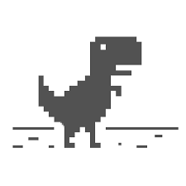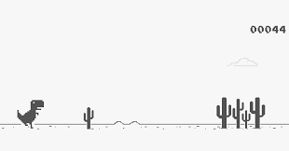

From what I found the game is also called T-Rex Runner, so I think its safe to assume that the dinosaur in this is a Tyrannosaurus Rex which belongs to the Theropods because the dinosaur has three toes. This is known to be a Theropod foot. T-rex belongs to the infraorder Coelurosauria and the family Tyrannosauridae. It had large hindlimbs, small forelimbs, small eyes, and a giant head. The reconstruction isn’t very accurate as it’s a 2d sprite, but the proportions of the body, legs and head seems to match that of a T-Rex. Like the real-life counterpart, its tail seems a bit on the shorter side, but the width of its tail seems appropriate to the rest of its body. In one of the lectures, they talked about the way T-Rexes might have sounded and that instead of opening their entire mouth and roaring they might have used low-pitched frequency sounds to communicate across large vistas, and to strike fear into the prey. In this representation the dinosaur seems to have its mouth open, which is another reason why it’s not exactly accurate. Unfortunately, the dinosaur doesn’t make a sound in this game so I can’t say whether it is accurate in that way or not. I would like to see a 3d version of the T-Rex with sharp teeth and better proportions. The dinosaur being a carnivore, I would have liked to see some sort of animal running away from it. But while it lacks detail in its simplicity it conveys that it is a T-rex. From this reconstruction we can see that the dinosaur had extraordinarily strong hind limbs which allowed the dinosaur to move and fast speed despite its enormous size and weight. But while the T-rex might have been able to run like this reconstruction in real life it didn’t jump as high as its height in vertical jumps.

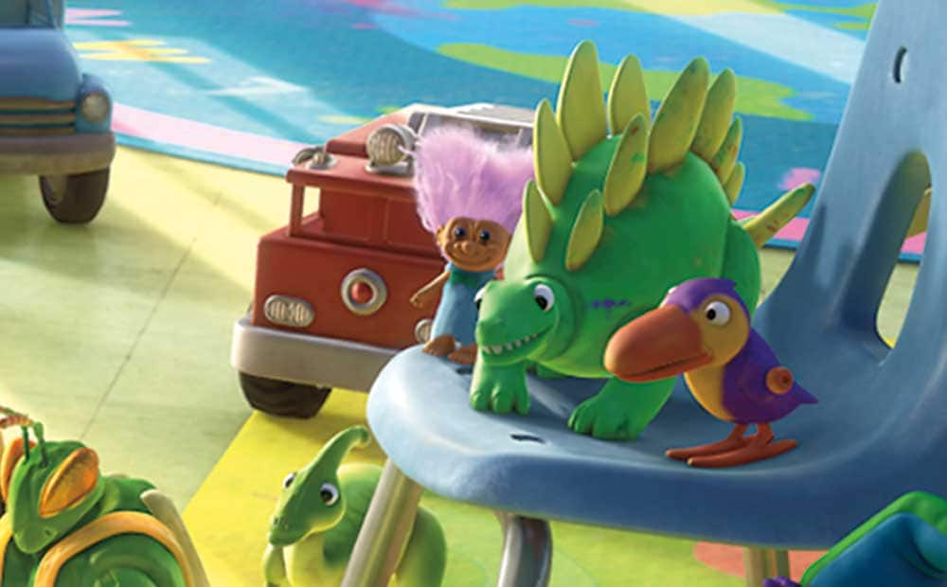

This dinosaur makes a cameo in the movie Toy Story 3 a hit Pixar movie that came out in 2010. I think this dinosaur is a stegosaurus meaning “roofed lizard” belonging to the thyreophorans which fall under the armored dinosaurs. The infraorder is Stegosauria. The stegosaurus is a quadrupedal dinosaur with kite shaped plates running across the back of its spine. I think this dinosaur belongs in this fauna because of its armor plates. The dinosaur has spiked at the end of its tail which seems to be missing in the reconstruction, but it does seem to have a long tail. If looking at the body proportions, the reconstruction is fairly accurate. The toy similar to the dinosaur has small forelimbs and long hind limbs, we can notice this as its joints at the back seem to be higher than the front joints. It has a small head compared to its body which is accurate. The reconstruction seems to be missing the smaller armor pieces at the back of a stegosaurus neck. The real dinosaur unlike its reconstructed toy seems to have an almost beak like mouth. While we don’t the know the exact color that the stegosaurus boasted, its doubtful that they had bright green skin and yellow armor this too I believe falls under inaccurate reconstruction. This herbivore ate plants low to the ground, thus the position of the head closer to the ground. There isn’t much wrong with the representation, it can be identified as a stegosaurus. But I would have liked a tail with spikes and a more beak like mouth this would greatly improve the reconstruction in my opinion. There was one lecture which showed how they could have flushed their armor plates with color to intimidate the predators, if true that would also be a great addition to make this representation even better.

I placed this dinosaur in this fauna because of the plates and rounded back. The stegosaurus meaning, “roofed lizard” has two pairs of spikes at the end of its tail. The reconstruction was very accurate to what we learned about this dinosaur. The tail of the to be a little flexible which is like the real flexible tail that dinosaurs have. The reconstruction being from Jurassic Park was accurate. One thing that stood out to me was how the dinosaur as a toy was heavy built, had small forelimbs, and a long tail. The spikes are pointing outward to defend. The reconstruction was inaccurate in what the tail was showing because the tail of the dinosaur must be in the air, but this tail was dragging on the ground. They added spots to the dinosaur too in the reconstruction and made the plates look like they were different colors. This isn’t proven, but to show the design of what the plates would have looked like makes sense.

I believe this was a good attempt. This reconstruction shows a narrow skull, small compared to the body, which is what the dinosaurs had to eat low vegetation because they were herbivores. The position of the skull is lower than the body. This dinosaur is hard to in – accurately portray because it has many features that prove it is a stegosaurus. To make this reconstruction better, there could have been a button to make the plates turn colors or have the tail moving around. This would have been more accurate because one lecture showed that they could have flushed color to their plates to intimidate predators. This reconstruction was accurate enough to show what the dinosaur is without telling what it is supposed to be.